**Letter of Assurance - Braunton Academy**

**Letter of Assurance**

Date: 4/7/25

Address: Next Steps Education Ltd, 4, Bridgeland Street, Bideford, Devon, EX39 2PS

Dear Head Teacher

**Safeguarding and Safer Recruitment: Letter of Assurance**

In accordance with the requirements of the DfE guidance Keeping Children Safe in Education and the Childcare Disqualification Requirements – Disqualification under the Childcare Act 2006, and for the purposes of Ofsted, I can confirm that Dr Liz Fancourt / Mrs Ellan Saunders undertaken all the necessary safeguarding, safer recruitment and vetting checks for all Next Steps Education Ltd employees who work at our Alternative Learning Provision.

These checks include;

* Enhanced DBS Disclosures
* Verification of identification checks
* Right to Work in the UK checks
* Where applicable, relevant qualification and registration checks

All **Next Steps Education Ltd** staff attending schools during the course of their employment will be able to provide photo identification.

Below is a list of confirmed staff with their current enhanced DBS clearance checks:

David Lyons

Beth Woollham

Yours sincerely

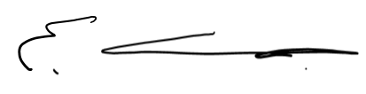

Dr Liz Fancourt

Director, Next Steps Education Ltd

UKPRN: 10091908